**FIGMA**

**Form Name : Login**

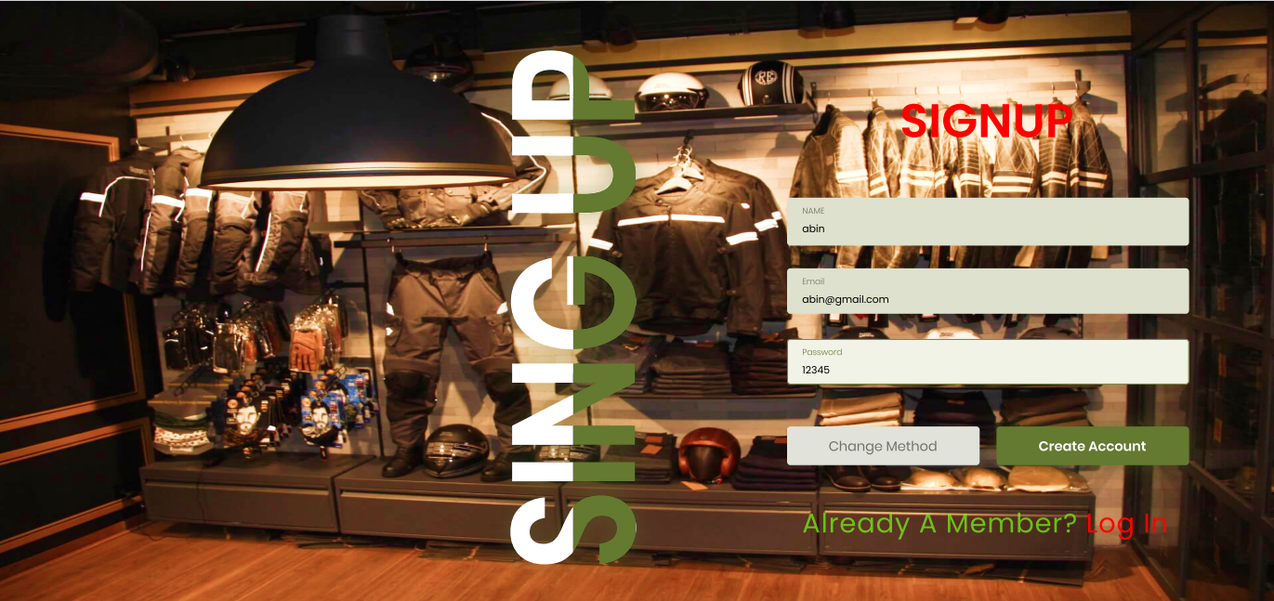

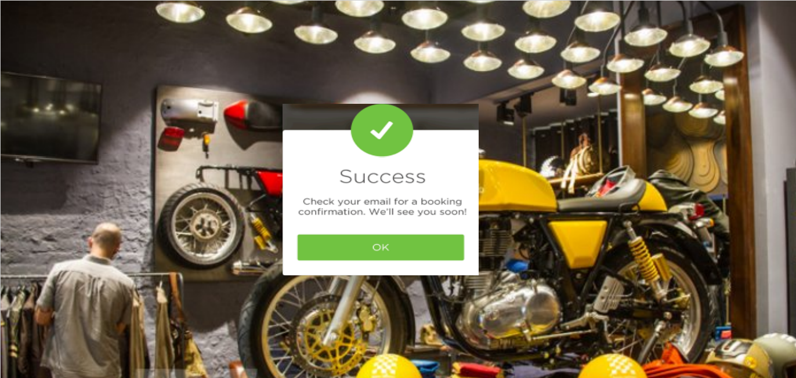

**Form Name : Home Page**

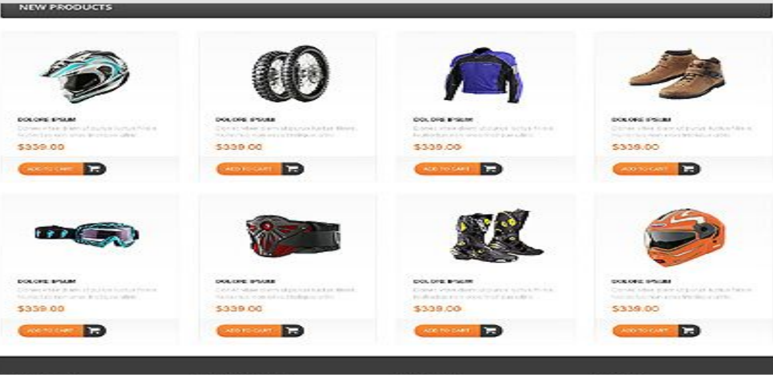



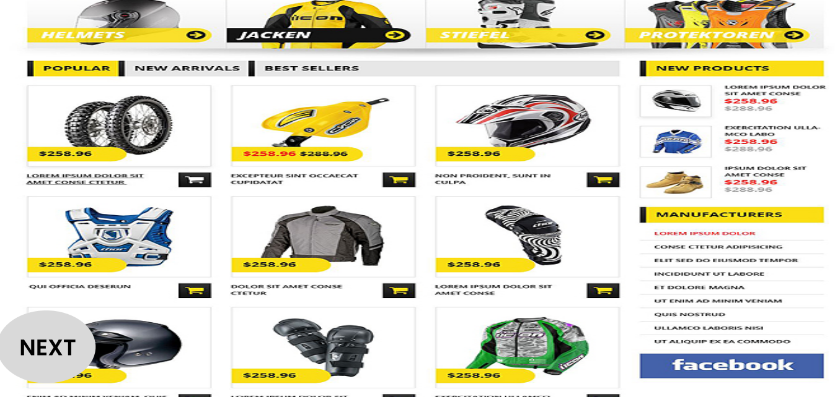

**Selenium Testing**

Selenium is an open-source, automated, and valuable testing tool that all web application developers should be well aware of. A test performed using Selenium is usually referred to as Selenium automation testing. However, Selenium is not just a single tool but a collection of tools, each catering to different Selenium automation testing needs. In this tutorial you will learn all about Selenium and the various types of Selenium automation testing tools.

**Test Case 1: Login by admin**

**code**

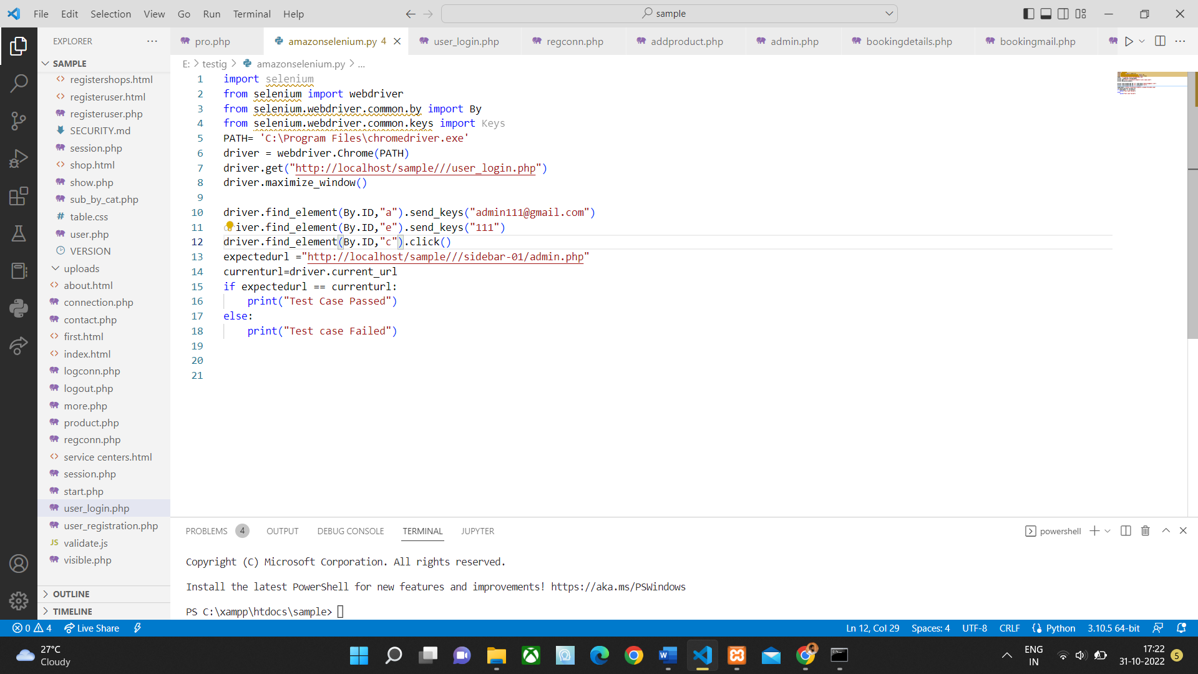

**Screenshot**

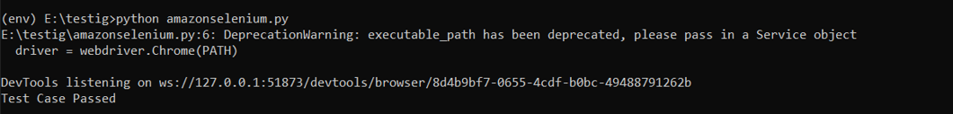

**Test report**

|  |  |  |  |  |  |
| --- | --- | --- | --- | --- | --- |
| **Test Case 1** | | | | | |
| **Project Name: Trials Frontier** | | | | | |
| **Login Test Case** | | | | | |
| **Test Case ID: Test_1** | | | **Test Designed By:** Abinmon Bousally | | |
| **Test Priority(Low/Medium/High):**  High | | | **Test Designed Date:** 31/10/2022 | | |
| **Module Name**: Login | | | **Test Executed By:** Navyamol KT | | |
| **Test Title: Login Test** | | | **Test Execution Date**: 31/10/2022 | | |
| **Description:** Testing the login module | | |  | | |
| **Pre-Condition:** Admin has valid username and password | | | | | |
| **Step** | **Test Step** | **Test Data** | **Expected Result** | **Actual Result** | **Status(Pass/**  **Fai l)** |
| 1 | Navigation to login page |  | User should be able to login | User is navigated to index page with successful login | Pass |
| 2 | Provide valid username | Username:  [admin111@gmail.com](mailto:admin111@gmail.com) |  |  | Pass |
| 3 | Provide valid password | Password:  111 |
| 4 | Click on login button |  |
| **Post-Condition: User is navigated to the index page** | | | | | |

**Test Case 2: Registration**

**Code**

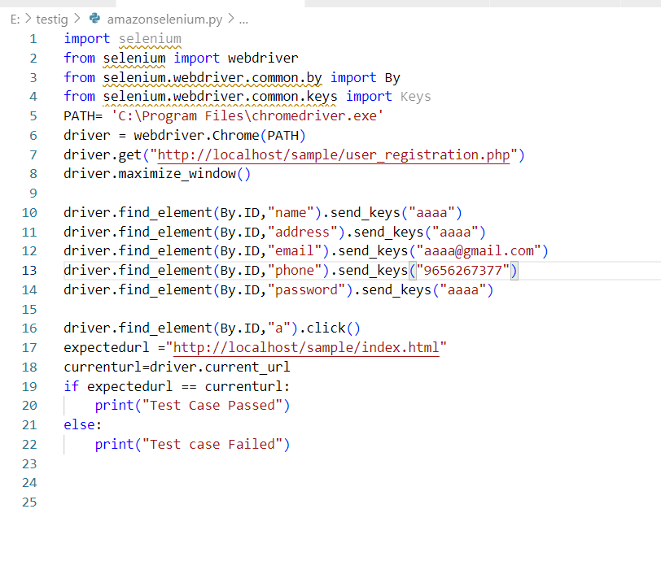

**Screenshot**

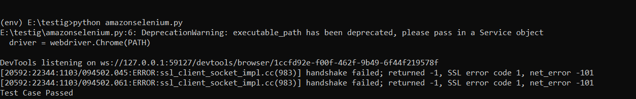

|  |  |  |  |  |  |
| --- | --- | --- | --- | --- | --- |
| **Test Case 2** | | | | | |
| **Project Name: Trials Frontier** | | | | | |
| **Registration Test Case** | | | | | |
| **Test Case ID: Test_2** | | | **Test Designed By:** Abinmon Bousally | | |
| **Test Priority(Low/Medium/High):**  High | | | **Test Designed Date:** 31/10/2022 | | |
| **Module Name**: Registration | | | **Test Executed By :** Navyamol KT | | |
| **Test Title :** Registration test | | | **Test Execution Date:** 31/10/2022 | | |
| **Description:** Testing the registration module | | |  | | |
| **Pre-Condition :**admin has invalid credentials | | | | | |
| **Step** | **Test Step** | **Test Data** | **Expected Result** | **Actual Result** | **Status(Pass/**  **Fai l)** |
| 1 | Navigate to index page |  | User should  be able to register and navigate to index page | User is navigated to index page after registration  successfully | Pass |
| 2 | Provide valid  username | Username:  aaaa |  |  |  |
| 3 | Provide valid  address | Address:  aaaa |  |  |  |
| 4 | Provide valid email | Email:  aaaa@gmail.com |  |  |  |
| **5** | Provide valid phone number | Phone number:  9656267377 |
| 3 | Provide correct password | Password:  aaaa |
| 4 | Click on submit button |  |
| **Post-Condition:** User is navigated to index page after registraction | | | | | |

**Test Case 3: user login**

**Code**

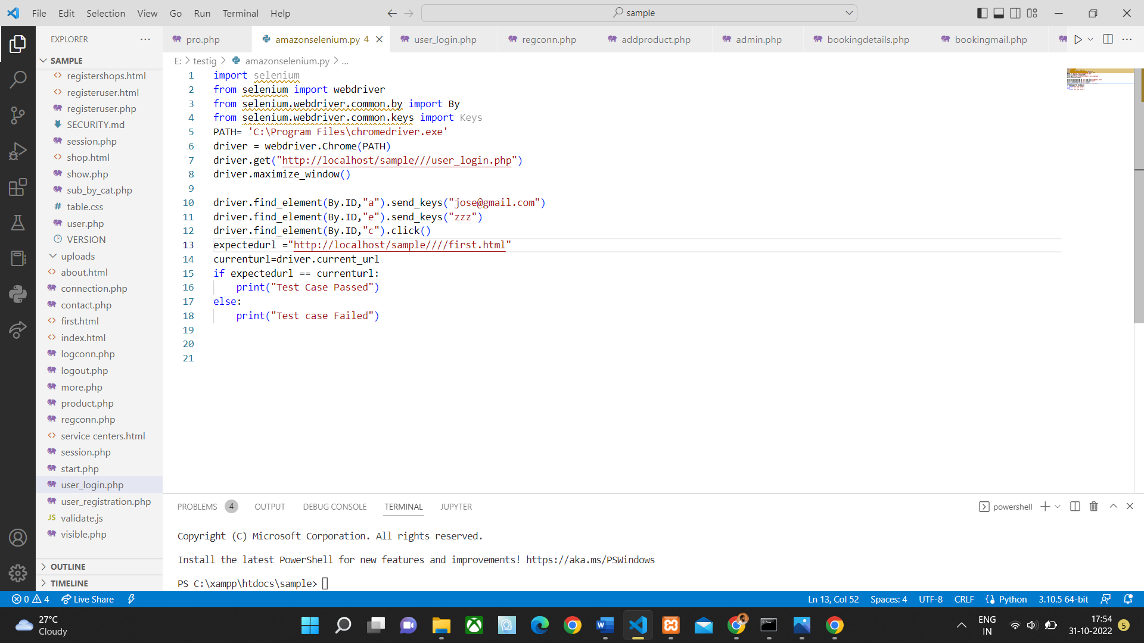

**Screenshot**

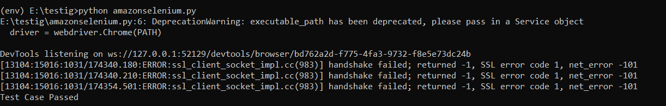

|  |  |  |  |  |  |
| --- | --- | --- | --- | --- | --- |
| **Test Case 3** | | | | | |
| **Project Name: Trials Frontier** | | | | | |
| **Login Test Case** | | | | | |
| **Test Case ID: Test_3** | | | **Test Designed By: Abinmon Bousally** | | |
| **Test Priority(Low/Medium/High):**  **High** | | | **Test Designed Date: 31/10/2022** | | |
| **Module Name**: Login | | | **Test Executed By : Navyamol KT** | | |
| **Test Title : Login Test** | | | **Test Execution Date: 31/10/2022** | | |
| **Description: Testing login module** | | |  | | |
| **Pre-Condition :**User has valid username and password | | | | | |
| **Step** | **Test Step** | **Test Data** | **Expected Result** | **Actual Result** | **Status(Pass/**  **Fai l)** |
| 1 | Navigate to login page | Username:  jose@gmail.com | User should be able to login | User is navigated to index page with successful login | Pass |
| 2 | Provide valid username | Password:  zzz |  |  |  |
| 3 | Provide correct password |  |
| 4 | Click on login button |  |
| **Post-Condition:** User is navigated to the index page | | | | | |

**Test Case 4: Contact**

**Code**

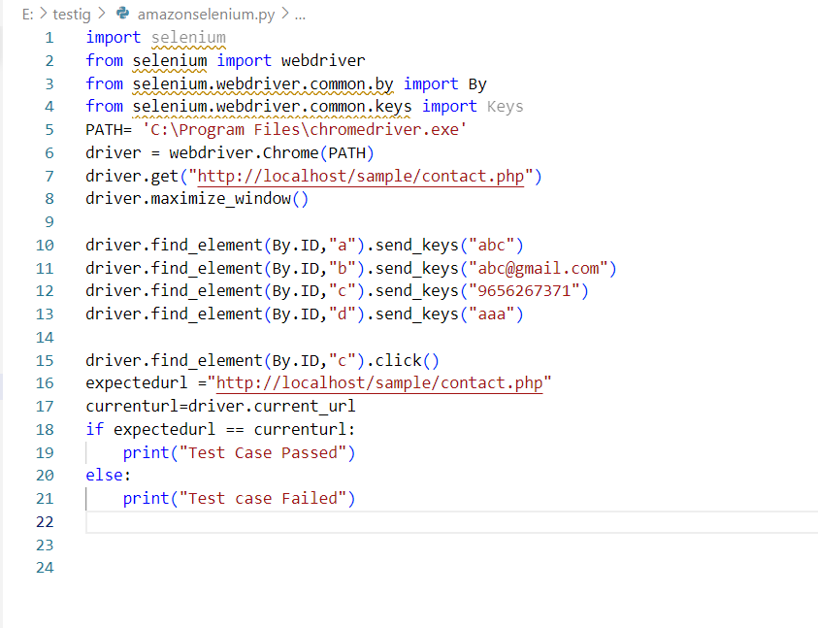

**Screenshot**

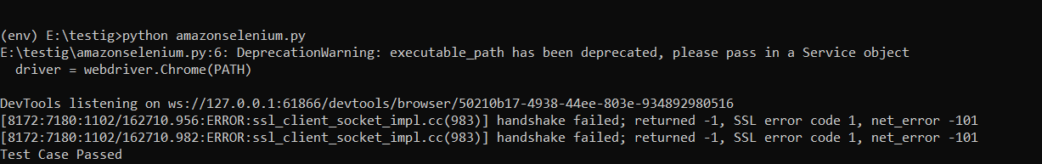

|  |  |  |  |  |  |
| --- | --- | --- | --- | --- | --- |
| **Test Case 4** | | | | | |
| **Project Name: Trials Frontier** | | | | | |
| **Contact Test Case** | | | | | |
| **Test Case ID: Test_4** | | | **Test Designed By: Abinmon Bousally** | | |
| **Test Priority(Low/Medium/High):**  **High** | | | **Test Designed Date: 31/10/2022** | | |
| **Module Name**: **Contact** | | | **Test Executed By : Navyamol KT** | | |
| **Test Title : Contact test** | | | **Test Execution Date: 31/10/2022** | | |
| **Description: testing the Contact module** | | |  | | |
| **Pre-Condition :** valid credentials | | | | | |
| **Step** | **Test Step** | **Test Data** | **Expected Result** | **Actual Result** | **Status(Pass/**  **Fai l)** |
| 1 | Navigate to contact page |  | User should be able to enter contact details and message | After entered details user navigated back to contact page  successfully | Pass |
| 2 | Provide valid name | Name:  abc |  |  |  |
| 3 | Provide correct contact details (email) | Email: abc@gmail.com |
| 4 | Provide correct contact number | Phone:  9656267371 |
| 5 | Message | Message:  aaa |
| 6 | Click on Submit Button |  |
| **Post-Condition: User is navigated back to contact page successfully** | | | | | |